10/17/2019
Country Report: Optimal Industry Development Strategy for South Africa

Heyang Huang, Soulaymane Kachani, Lun Li, Jiayu Zhao Economic Complexity lab
Columbia University
Optimal Industry Development Strategy for South Africa

0. Executive Summary

In this report, we aim to uncover the economic path South Africa went through during the period from 2009 to 2014. Specifically, we dive into the topic through a macroeconomic overview of South Africa from the perspective of Gross Domestic Product (GDP) and Economic Complexity Index (ECI), which reflect countries’ production capability and production structure, respectively. We find that during the period of our interest, South Africa demonstrated a low level of economic growth with an annual GDP growth rate of 3.39%, concurrent with a decrease in economic complexity as compared with other major economies in Africa.

The lack of economic progress during the period, we believe, can be partially explained through analysis of the economic and product complexity structure of South Africa on the industry group level. The product classification system we adopt allows us to measure the realized industry development for various industry groups and to observe that South Africa invested heavily in developing animal, food and raw manufacturing industry groups during the period, while its emerging peers and developed economies around the globe have adopted much more complex and progressive paths.

Based on our analysis of the opportunity gain and a sensitivity analysis of major industry groups, South Africa can further its gains by prioritizing Services and Utilities, High-complexity Products and Daily Instruments. We further note that South Africa has an ill-matched development strategy that indicates a particularly low level of structural optimality on the complexity level, having an adjusted R-square of merely 1.3%. Since a significant positive correlation exists between five-year GDP growth and the structural optimality index of an economy as we define and calculate, South Africa indeed has a suboptimal growth experience as compared with fast-growing economies both on a regional scale and on a global scale, and has the potential to further its economic gains through industrial structure optimization as suggested in the paper.

1. Report Overview

In this report, we aim to uncover the economic path South Africa went through during the period from 2009 to 2014. Specifically, we dive into the topic through a macroeconomic overview of South Africa from the perspective of Gross Domestic Product (GDP) and Economic Complexity Index (ECI), which reflect countries’ production capability and production structure, respectively. We then analyze the industrial framework and changes of South Africa during the period based on quantitative measures such as Product Complexity Index (PCI) and Product Family Complexity Index (PfCI), followed by a detailed analysis of how such changes have matched with development strategies as quantitatively measured by opportunity gains on an industry-level. We conclude our report with macro-level results and predictions of South Africa, as deduced from regression models we have established on a global scale, which take into account countries’ stances in their product space.

2. Macroeconomic Results

2.1 GDP Ranking and Changes
As the 3rd largest economy in Africa by GDP, South Africa has a GDP of 297.22 billion USD in 2009 and 351.12 billion USD in 2014, exhibiting a promising level of economic output. Figure 1 illustrates the time-series GDP results for top African countries from 1996-2016, and South Africa ranks among its counterparts as a major African economy. However, the period from 2009 to 2014 seems to be a rather stagnant period for South Africa in terms of GDP growth as compared with its emerging peers. During the five years, South Africa exhibited an annual GDP growth of 3.39%, far below the annual growth rate of the other five leading African economies, which have a geometric annual average growth rates of 12.22%. Also, South Africa’s GDP ranking in a global scale shifted from the 31st to the 34th place from 2009 to 2014, confirming a lack of economic progress during the period. The mild economic growth during the period, we believe, can be reflected through changes in ECI and PCI, and can be further explained by mismatched production strategies adopted by South Africa during the period, which we will expand at the later stage of the report.

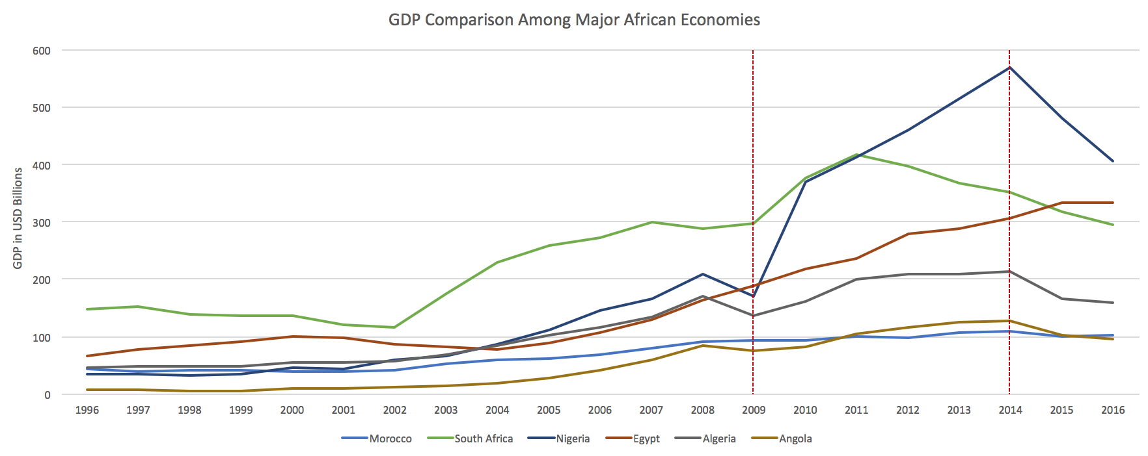

Figure 1: GDP Comparison Among Major African Economies

2.2 ECI Ranking and Changes
The Economic Complexity Index (ECI), as defined by Ricardo Hausmann and Cesar Hidalgo in 2009 to explain the knowledge accumulated in a country's population, exhibits similar pattern for South Africa. As illustrated in the Figure 2 below, South Africa exhibits a mild decrease in terms of its production capability from 2009 to 2014, as measured by ECI. This is in direct contrast to countries such as Nigeria, which demonstrates overwhelming advantage over South Africa for growth in both the GDP and the ECI indicators.

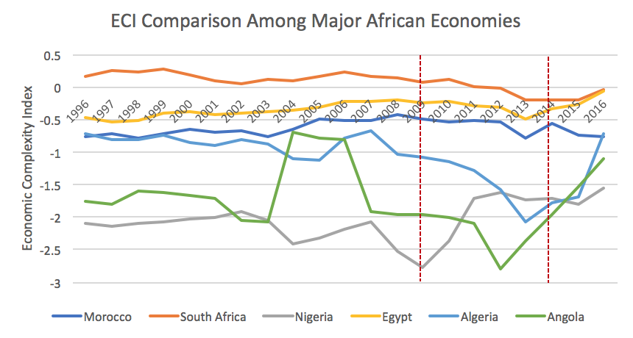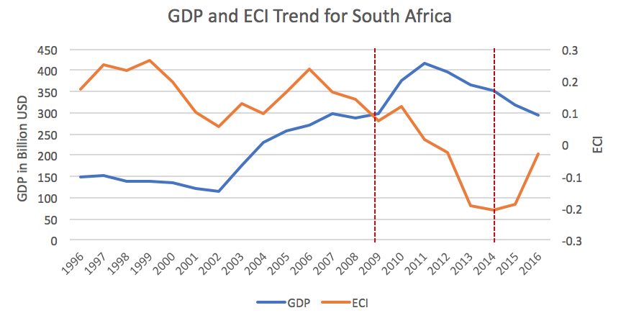

Figure 2: ECI Comparison Figure 3: GDP and ECI (South Africa)

Figure 3 offers a further comparison of GDP and ECI over the entire time span from 1996 to 2016 for South Africa. The decrease in GDP during the period from 2009 to 2014 is accompanied by a similarly significant decrease in ECI, indicting the potential that the mild economic stagnation experienced by South Africa during the period from 2009 to 2014 might be attributed to its low ECI, or the ineffectiveness of the country in developing a competitive product space that helps to accumulate complicated knowledge and technology. In order to provide a more concrete answer to why this has happened, we will dive into an analysis of South Africa’s production structure and its product space designs in the next few chapters.

3. Production Analysis

3.1 Product Categorization
Our main data source in this research is the UN Comtrade Website (https://comtrade.un.org), which provides us with valuable information on countries’ export values on an annual basis, including highly specific export data for more than 5000 categories of products. In order to have a holistic vision of the product space of a country, however, a level of categorization is required. Product in our data source are labelled from 010000-999999, with the first two-digits representing a general category to which the product belongs. Based on the 99 categories as extracted from the label, we further group the products into 18 most widely-accepted industries, as summarized in Table 1.

Note that the High-complexity Products industry group is not a distinct industry but rather an aggregated industry that encompasses the most complicated products from the most technologically-advanced industries (as measured by PCI). This industry serves as an indicator for us to quantitatively evaluate how well a country has performed in developing cutting-edge technologies and closing its technical gap with advanced economies, which has become a topic of wide concern today. Indeed, when we rank the 18 categories based on PfCI (an equivalent concept of PCI as calculated based on the 18 categorized product groups), High-complexity Products industry has the highest PfCI among all industry groups.

Category | Description
Animals and By-products | All kinds of meat, livestock and related by-products
Vegetables, Fruits and Plants | All kinds of plants, edible vegetables and fruits
Food and Preparations | Edible preparations, raw cooking materials and appliances
Clothing and Accessories | All kinds of fabrics, filament, clothing and accessories
Textiles | All kinds of textile articles and related products
Wood Products | Book, paper and other elementary products related to wood
Metals | Mining of all sorts of raw Metals
Refined and Processed Stones | Refined or processed stone products such as pearl and ceramics
Energy Drilling and Mining | Mining industry for energy, minerals, stone materials, etc.
Daily Instruments | Basic daily instruments such as sport requisites, timing and measuring tools
Raw Manufacturing | Basic products made from plastic, rubber, leather, etc.
Chemical Manufacturing | Advanced chemical products and pharmaceutical products
Chemicals | Raw chemical materials and by-products
Machinery and Construction | Machinery and mechanical appliances, including electrical equipment
Transportation | Vehicles and locomotives including aircraft, ship, railway, etc.
Weapons | Explosives, arms and ammunition
Services and Utilities | Financial, business, legal, communication, travel Services and Utilities, etc.
High-complexity Products | Agglomeration of advanced products with highest PCIs

Table 1: Categorization of Products

We further observe a strong positive correlation between the GDP and the export of High-complexity Products. As shown by Figure 4 below, a high adjusted R-square of 67.6% exists between GDP and High-complexity Products exports, indicating that more successful economics, as measure by GDP, tend to be those that are capable of producing and exporting High-complexity Products as we define them.

Statistics | Value
Multiple R | 0.824
R-Square | 0.679
Adjusted R² | 0.676
Variable | Value
Coefficient | 12.20
t-stat | 15.61
P-value | 0(***)


Figure 4: Regression of GDP and High-complexity Products Exports

3.2 Realized Industry Development
Based on the product categorization aforementioned, we aim to capture South Africa’s realized industry production strategy between 2009 and 2014 on a complexity level. In Hausmann and Hidalgo (2009), distance is defined to be a measure of how far a country is from a certain product not in its product space. We extend this concept to all product groups and quantify how technically equipped a country is to develop the corresponding product groups. In other words, the shorter the distance between a country and a product group, the more capable a country is in developing products within that group. Defining this net distance change as the Realized Industry Development (RID), our export data allow us to calculate and compare RID of South Africa and the 18 product groups in 2009 and 2014 through subtraction, where a positive RID indicates a shortening of the distance (i.e., advancement of the industry), and a negative RID indicates the reverse. As ranked in Table 2, during the period from 2009 to 2014, South Africa has focused mostly on products of low complexity and those requiring basic skills, including daily food consumption products, its raw manufacturing industry and products related to Metals.

Category | RID | Category | RID
1. Animals and By-products | 0.056 | 2. Raw Manufacturing | 0.045
3. Daily Instruments | 0.037 | 4. Food and Preparations | 0.033
5. Vegetables, Fruits and Plants | 0.030 | 6. Textiles | 0.022
7. High-complexity Products | 0.021 | 8. Clothing and Accessories | 0.016
9. Chemical Manufacturing | 0.010 | 10. Transportation | 0.005
11. Wood Products | 0.002 | 12. Metals | -0.001
13. Weapons | -0.003 | 14. Machinery and Construction | -0.004
15. Energy Drilling and Mining | -0.012 | 16. Services and Utilities | -0.020
17. Chemicals | -0.038 | 18. Refined and Processed Stones | -0.059

Table 2: Realized Industry Development (RID) of South Africa

3.3 Regional and Global Comparison
Table 3 and 4 below summarize how the production strategy adopted by South Africa compares with its African counterparts and a selected group of leading economies in the world, as measured in RID. It can be directly observed that South Africa focused on products with moderate level of complexity level, when compared against its African counterparts such as Nigeria and Egypt, which gave a considerable level of attention to basic product groups such as Animals and By-products.

Ranking | South Africa | Egypt | Morocco
1 | Animals and By-products | Animals and By-products | Chemical Manufacturing
2 | Raw Manufacturing | Services and Utilities | Refined and Processed Stones
3 | Daily Instruments | Weapons | Wood Products
4 | Food and Preparations | Vegetables, Fruits and Plants | Textiles
5 | Vegetables, Fruits and Plants | Energy Drilling and Mining | Clothing and Accessories

Table 3: RID Comparison on a Regional Scale

Ranking | The United States | Germany | Singapore
1 | Services and Utilities | Chemicals | Machinery and Construction
2 | Chemical Manufacturing | Services and Utilities | Transportation
3 | Food and Preparations | High-complexity Products | Daily Instruments
4 | Textiles | Transportation | Chemicals
5 | Clothing and Accessories | Food and Prep | High-complexity Products

Table 4: RID Comparison on a Global Scale

Table 4 further examines South Africa’s development strategy against those of more developed economies on a global scale. Reasonably, developed economics such as the United States, Germany and Singapore have devoted the majority of their efforts into highly complicated industry groups while emerging economies such as China still partially rely on basic industry groups like Refined and Processed Stones. This trend holds true in general, regardless of the continent or the time period, and serves as an indicator for which phase of development a country is currently in as evaluated from its production strategy. Based on this standard, South Africa is indeed adopting a moderate strategy that seeks development in its intermediate-level industry groups.

4. Product Space Design

4.1 Suggested Development Vector
As aforementioned, distance gives us an idea of how far each new product is from a country’s current mix of exports. As defined in Hausmann and Hidalgo (2009), distance is “the weighted proportion of products connected to goods p that country c is not exporting, i.e., MCP=0.” Based on this definition, the distance between a country and any product that the country is currently exporting (i.e., the country is a significant exporter in the product as compared to global average) is zero. Similarly, opportunity gain quantifies the contribution of a new product in term of opening up the doors to more and more complex products. Intuitively, a product that a country is currently exporting (i.e., MCP=1) has an opportunity gain of zero. And unreasonable investment on certain product p would lead to a relative decrement in export of more profitable products, and therefore lead to a negative opportunity gain of product p. The opportunity gain is not the only estimator of a country’s level of economic development. However, among countries with comparable economics strength, those having higher ECI, or in other words, more reasonable economics structures are often in better shape.

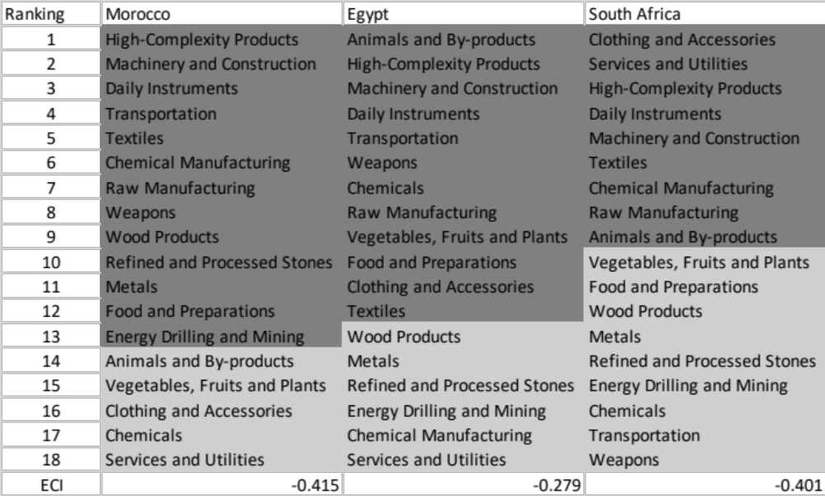

Table 5: Opportunity Gain Ranking on a Regional Scale

We define the ranking of opportunity gain for a country c, as the Suggested Development Vector (SDV) of c. Table 5 and 6 summarize how the SDV of South Africa compares with a selected group of regional economies and leading economies in the world, with the industry groups ranked in decreasing order of significance. Dark grey indicates positive opportunity gain, gray indicates zero opportunity gains, and light grey indicates negative opportunity gains. The result shows that leading countries barely have any industries with positive opportunity gain. In other words, those countries are already in the most stable and efficient economic structure. Without the necessity of economic transition, those countries merely need to maintain a steady and balanced economic development. In contrast, developing countries have nearly half of industries with positive opportunity gain, and share common interests in industrial manufacturing and High-complexity Products industries. It can be concluded that South Africa shares the characters of developing countries, with a premature economics structure that leans towards basic to intermediate level industries.

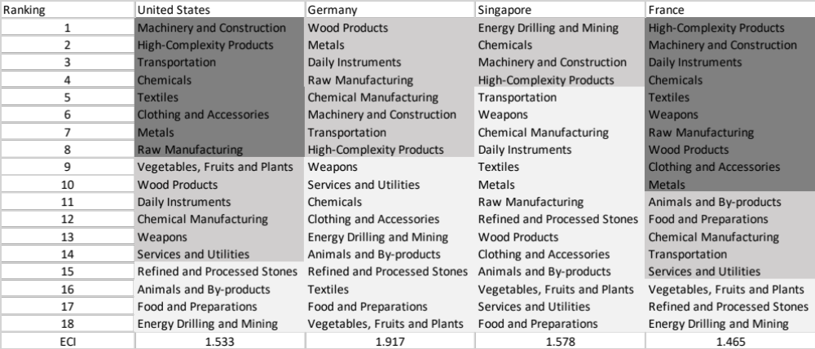

Table 6: Opportunity Gain Ranking on a Global Scale

4.2 Sequential Industry Development Strategy
The optimal sequential industry development strategy aims to approximate the most efficient order of industry development. As discussed in the previous section, opportunity gain measures the potential profit in terms of economic complexity when a country invests on a product p to an extent such that the MCP bumps up from 0 to 1 (i.e., the country becomes a significant exporter in that product). Obviously, the difficulty of bumping up MCP varies across industries. Therefore, we capture this variation of difficulty by defining the concept of marginal opportunity gains.

$$marginal opportunity gains_{cp}= \frac{opportunity gains_{cp}}{\left(\frac{minimum increment of export of product p for country c }{present export of product p for country c}\right)}$$

In each iteration, we order all 18 industries based on their current marginal opportunity gain, and prioritize the industry with the highest marginal opportunity gain. We increase the prioritized industry’s export to an extent that the MCP firmly bumps up to 1. Following the routine above, we derive the iterative strategy as shown in Table 6, ranked by marginal opportunity gains in decreasing order. Dark grey indicates positive opportunity gain, gray indicates zero opportunity gains, and light grey indicates negative opportunity gains.

4.3 Strategy Interpretation
Table 7 shows that at present South Africa lacks necessary industrial power, and therefore barely has advantage in manufactured goods. Basic products such as Textiles, closing and accessory are the foundation of intermediate-level products, and industries such as raw manufacturing and Daily Instruments are the second easiest step. As a result, gaining comparative edges in these industries will rocket the ECI of South Africa, and it is noteworthy that the significance of High-complexity Products drops extensively after the development of Services and Utilities re-opens the door of light industries and intermediate-level industries such as transportation, chemicals and manufacturing. Because South Africa has a large gap between its current product space and advanced product groups such as High-complexity Products and Machinery and Construction, it is extremely costly for South Africa to develop these two products even in the final stable stage, and South Africa may have a compelling industrial structure without a comparative edge in these two industry groups.

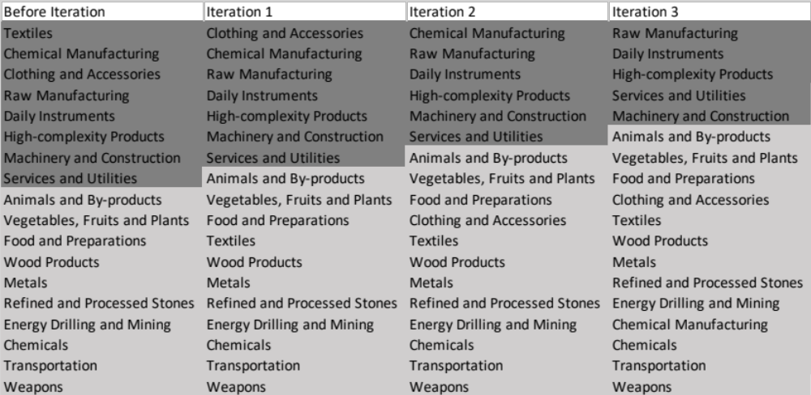
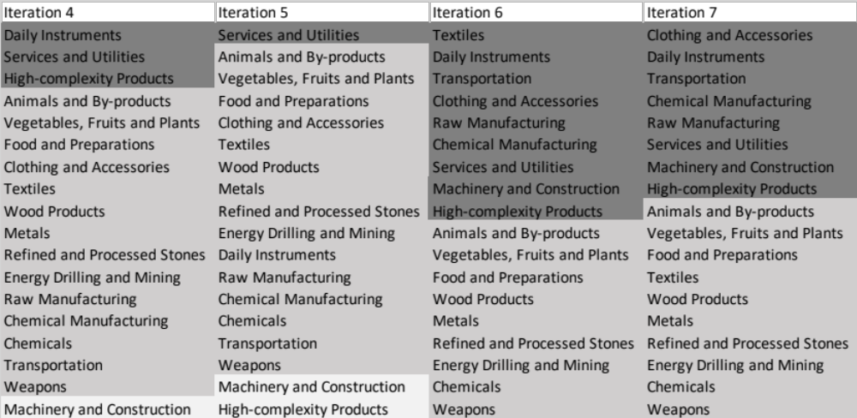

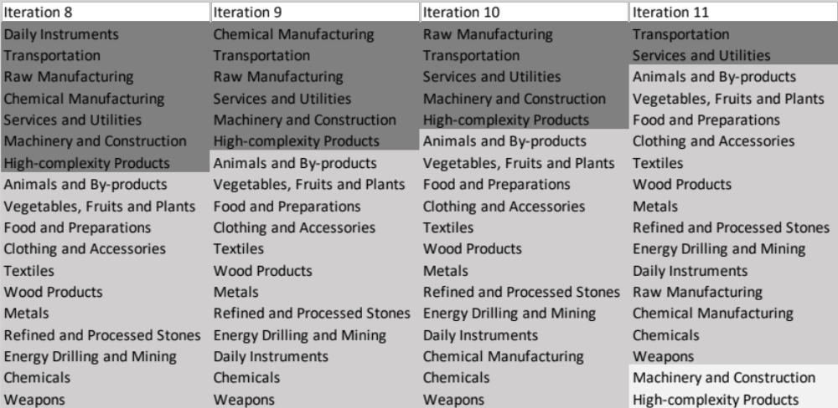

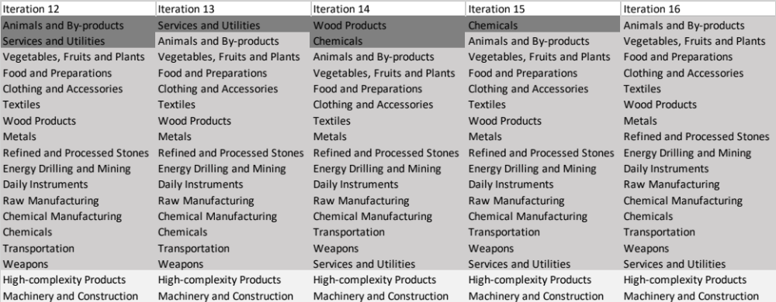

Table 7: Marginal Opportunity Gain in an Iterative Process

Note that High-complexity Products and Machinery and Construction show negative marginal opportunity gain at the final stable stage, but that does not mean the two industries are valueless for the development South Africa. Instead, the suggestion means that South Africa, given to its economic situation at the final stage, is encouraged to prioritize the other industries and develop those bottom two industries only after it builds a balanced economic structure in the first place. The industries with negative opportunity gains, though not prioritized in their particular stage, should therefore still be proportionately strengthened within the capability of the country and not left behind.

5. Macro-level Predictions

5.1 Structural Optimality Index
Indeed, such choice of prioritization has proven to be a significant factor in deciding the economic outcomes of countries. In order to quantitatively evaluate how effective our developmental strategies are and how deviations from the suggested developmental path will lead to non-optimal growth results, we define the measure – Structural Optimality Index (SOI) – on a country level as the R-Square obtained from regressing the country’s realized industry development over the suggested development strategy. Both strategies are quantified in nature, with the realized industry development represented by export increase in major industry groups and the suggested development strategy represented by the opportunity gains of developing the corresponding industry groups as calculated in previous sections. The R-square from the regression thus provides us with a concrete measure of how the development path adopted by the country has fitted with/differed from our suggestion.

After obtaining this measure for all countries in our database, we further regress countries’ five-year economic growth, which is defined as the net increase in GDP (USD), over their SOI. Figure 6 illustrates the regression output, which shows a strong positive correlation between countries’ SOI and their five-year GDP growth, significant at the 1% level and achieving an adjusted R² of 11.9%. In other words, the more a country develops as suggested by calculations on a complexity level, the better economic outcomes it achieves.

Statistics | Value
Multiple R | 0.355
R-Square | 0.126
Adjusted R² | 0.119
Variable | Value
Coefficient | 1.249*10¹²
t-stat | 4.061
P-value | 0.000(***)


Figure 6: Regression of Five-year GDP Growth over SOI

5.2 SOI of South Africa and Its Implications
South Africa, for instance, has a particularly low level of structural optimality as compared with its African peers. As the regression in Figure 7 suggests (the orange curve represents export increase and the blue curve stands for opportunity gain of the corresponding industry), South Africa demonstrates a low level of correlation with the suggested developmental path, having an adjusted R-square of merely around 1.3%. South Africa ranks the 88th place among all countries in terms of SOI and has the slowest economic progress among its African peers from 2009 to 2014 with an annual growth rate of 3.39%, which is consistent with the regression result in Figure 6. This is in direct contrast to emerging economies such as China, where there is a high SOI of around 82.8% and a corresponding GDP growth of 5.39 billion USD, making it one of the fastest developing economies during the period. In sum, South Africa’s stagnant economic progress from 2009 to 2014 can be at least partially explained by a mismatched development strategy that demonstrates a considerable level of deviations from our suggested developmental path. In specific, South Africa invested heavily in the stone industries, while it should have focused more on moderately complex industry groups such as Machinery and Construction and Daily Instruments and Services and Utilities.

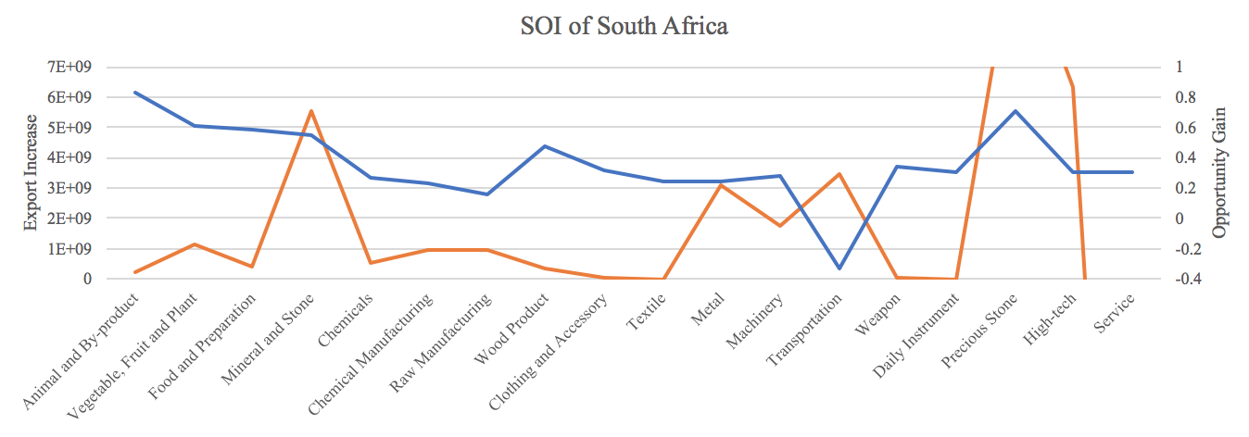

Figure 7: SOI of South Africa (2009-2014)

6. Concluding Remarks

In conclusion, South Africa has demonstrated a low level of economic growth in terms of GDP during the period from 2009 to 2014, concurrent with a stagnation in economic complexity as compared with other major African economies.

The lack of economic progress during the period, we believe, can be partially explained through analysis of the economic and product complexity structure of South Africa on the industry group level. The product classification system we adopts allow us to measure the realized industry development for various industry groups and to observe that South Africa invested heavily in developing animal, food and raw manufacturing industry groups during the period, while its emerging peers and developed economies around the globe have adopted much more complex and progressive paths.

Based on our analysis of the opportunity gain and a sensitivity analysis of major industry groups, South Africa can further its gains by prioritizing Services and Utilities, High-complexity Products and Daily Instruments. We further note that South Africa has an ill-matched development strategy that indicates a particularly low level of structural optimality on the complexity level, having an adjusted R-square of merely 1.3%. Since a significant positive correlation exists between five-year GDP growth and the structural optimality index of an economy as we define and calculate, South Africa indeed has a suboptimal growth experience as compared with fast-growing economies both on a regional scale and on a global scale, and has the potential to further its economic gains through industrial structure optimization as suggested in the paper.

References

Hausmann, R., Hidalgo, C., Bustos, S., Coscia, M., Chung, S., Jimenez, J., Simoes, A. and Yıldırım, M. (2007). The Atlas of Economic Complexity. [online] Atlas.cid.harvard.edu. Available at: http://atlas.cid.harvard.edu/.

Balassa, B., “The Purchasing Power Parity Doctrine - A Reapprais- al,” Journal of Political Economy 72, 584-596 (1964).

Feenstra, R.; Lipsey, R.; Deng, H.; Ma, A. & Mo, H. “World Trade Flows: 1962-2000” NBER working paper 11040. National Bureau of Economic Research, Cambridge MA (2005).

United Nations Commodity Trade Statistics Database (http://comtrade.un.org/db/), accessed in August 2019.

The World Economic Forum, “The global competitiveness report,” (various years).

Barro, R. & Lee, J-W. “A New Data Set of Educational Attainment in the World, 1950-2010,” NBER Working Paper No. 1590 (2010).

Kaufmann, D. & Kraay, A. “Governance Indicators: Where Are We, Where Should We Be Going?” Policy Research Working Paper 4370. Washington, DC: World Bank (2008).

Hanushek, E.A. & Woessmann, L. “The Role of Cognitive Skills in Economic Development,” Journal of Economic Literature 46(3), 607- 668 (2008).

